IID and GHTP  Room 543 - 730, Bannatyne Avenue  Winnipeg, MB, CANADA  R3E 0J9  Telephone: 1-204-977-5609  CIHR International Infectious Diseases & Global Health Training Program  Application Form  Complete Applications are due September 15. 2009. | 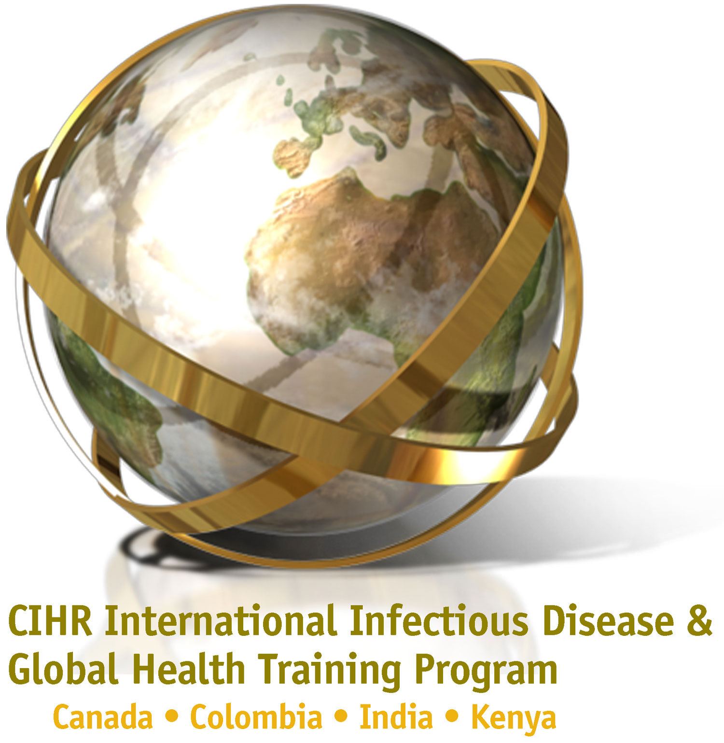

*Name:

*Mailing Address:

Permanent Address: (leave empty if same as mailing address)

*Date of Birth:
D D M M YYYY

*Country of Citizenship:

Telephone:

Facsimile:

E-mail:

Confirmed Mentor/Supervisor:

*Background/ Research Interest: (Please check one or more)
Basic Clinical Social Epidemiological sciences

Program Track: (Please check only one)

UM-Based Ph.D.

UM-Based PDF

UM-Based Clinical Fellow

International Ph.D.

International PDF

* Required entries.

